**Student Names and emails:**

* Mohammed Alsheraa, shewa@umich.edu
* Ellette Foucher, efoucher@umich.edu

**Introduction:**

* This project is implemented in C, designed to be cross-platform. The code was developed and tested on both Windows (using Visual Studio) and Linux (using Visual Studio Code), ensuring compatibility across the different operating systems.

**Running Instructions or using the Makefile:**

* gcc chewaTestServer.c -o chewaTestServer -lsqlite3 (for server)
* gcc chewaTestClient.c -o chewaTestClient (for client)
* ./chewaTestServer ./chewaTestClient
* For linux ssh terminal as shown in the video: gcc chewaTestServer.c sqlite3.c -o chewaTestServer -lpthread -ldl (the rest is the same)

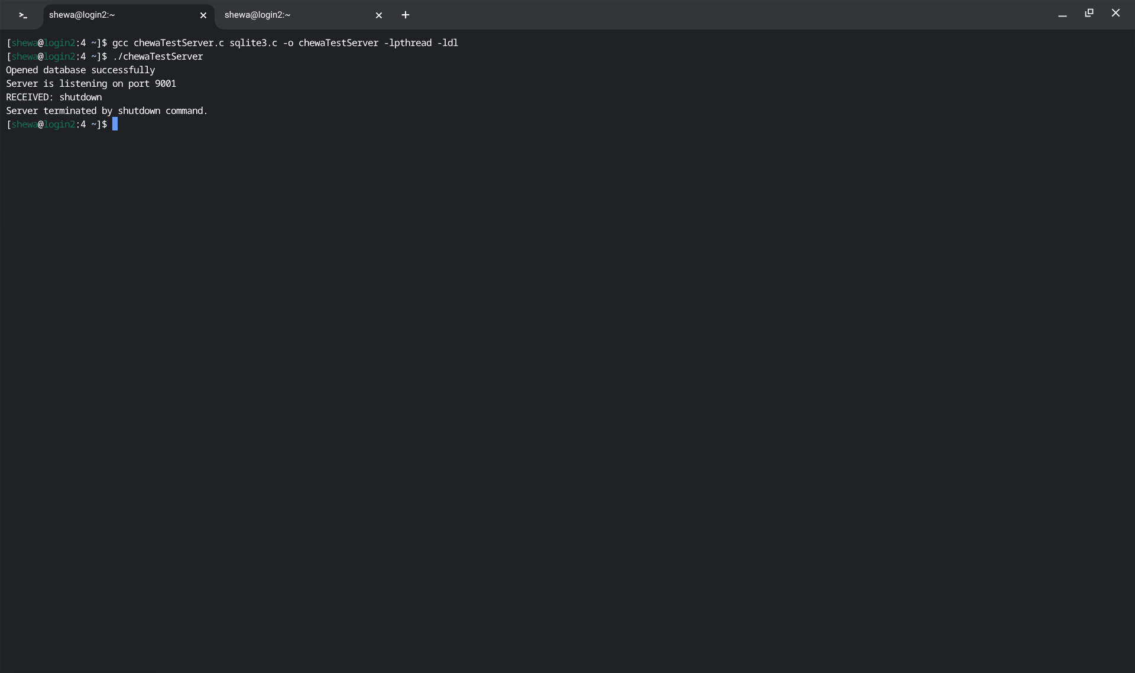

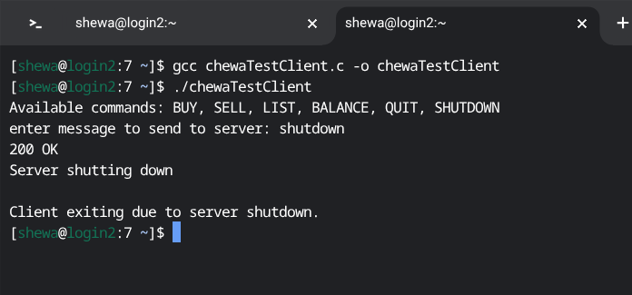

**Each Student’s role:**

* Mohammed Alsheraa - Implemented the following features:
  + handled the socket programming for both the server and client
  + Implemented the getbalance function
* Ellette Foucher - Implemented the following features:
  + Implemented functions for sell, buy, and list

**Bugs in the code:**

* No known bugs in the code.

**Youtube Link:**   
<https://youtu.be/yDxu7kkkCPQ>